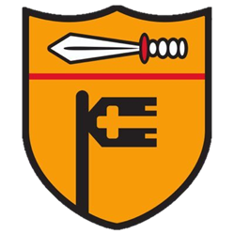

Eco Warrior
Newsletter

New Eco Warriors
At the start of the academic year, each class from Year 1 – Year 6 voted for two new Eco Warriors to represent their class for the year. The new Eco Warriors have already come up with a to-do list for the year, which includes: closely monitoring the recycling in classrooms, creating a new wildlife area behind the football field, and taking part in the Bambisanani Challenge again. Keep an eye on the school Twitter page and in the newsletter for updates on the Eco Warriors’ work!

Work So Far
In their very first meeting together, the Eco Warriors learned about Pope Francis’ encyclical Laudato Si', which calls on us to care for our common home and recognise our responsibility to protect God's creation.
Since then, the children have began work on the wildlife area behind the football field. The children have repurposed pieces of wood and wooden pallets to begin building their own bug hotel. They have started filling this hotel with pine cones and sticks to help create a welcoming habitat for bugs and insects. They are very excited to come up with a name for the hotel.

Half-termly Challenge As part of the Eco Warriors’ work, they will be setting the rest of the school a challenge to complete at home each half-term. This half-term’s challenge is to turn something you would normally throw away, like a cardboard box or empty packaging, into something useful or creative. Should you complete the challenge, make sure to bring your creation to Mr Wardell for a chance of winning a prize.

