The Eco-Committee decided on four main goals for the school year in their very first meeting:
- to improve recycling in classrooms.
- to help with a project at Nunroyd Park
- to increase learning on Global Citizenship.
- to make a school a welcoming place for different animals.

To help improve the recycling in class, the Eco Warriors came up with two ideas- firstly to create new posters for each bin explaining what can and can't be put in each bin, and secondly actually moving the bins away from each other, so that all rubbish doesn't just get thrown in the same bin. They implemented these strategies early on in the academic year and are keen to monitor how successful they are.

When the prospect of visiting Nunroyd Park was mentioned during the first meeting of the year, the children were very excited. Just before Christmas, the children made their first visit there as Eco Warriors Whilst there, they met with volunteers Graham and Christine from the Friends of Nunroyd Park group who help to maintain the park. The volunteers talked to the children about all the work they do, and then they put the children to work! The Eco Warriors put some food out for the birds and the squirrels, and were fortunate enough to see a Robin, and also helped clear away litter from around the cricket club. The volunteers were impressed with the children's attitude, and are looking forward to having them back again soon.
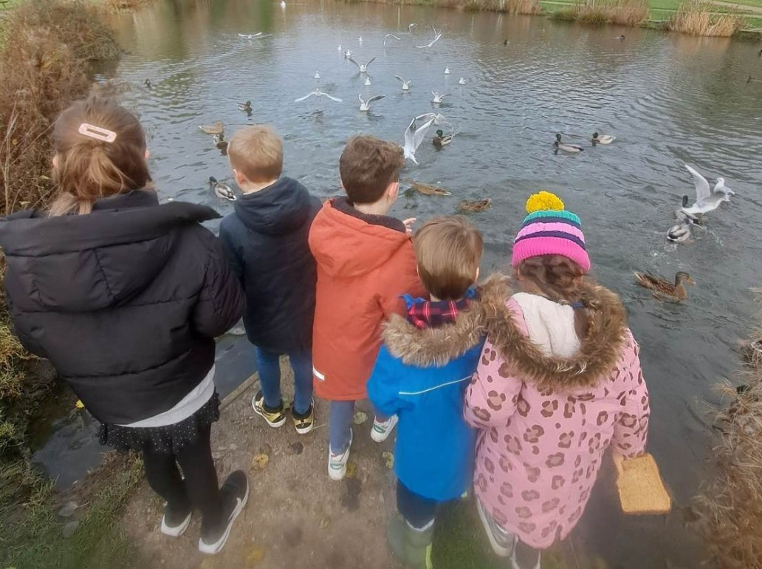

In terms of Global Citizenship, the children discussed the importance of learning about different cultures. Mr Wardell then introduced them to the Bambisanani Partnership, which uses sport to help develop international understanding, education, health and leadership. The children are very excited about starting this project.

The Eco Warriors have very much enjoyed their work on Biodiversity and helping to make school a welcoming place for different forms of wildlife. At the beginning of the school year, the children completed a wildlife walk to see what different plants and animals they could find, with the most exciting find being a huge spider! The Eco Warriors are eager to create some more habitats for these animals, and have started to make their own bug hotels out of recycled plastic bottles. These just need filling with natural materials once the weather has dried and then they will be placed around the school grounds.
Mrs Lloyd has helped the Eco Warriors with their Biodiversity work by organising for children to take part in the RSPB's Big School Birdwatch. During science lessons and at lunchtime, the children loved observing the different species of birds and keeping a tally of how many they saw. The children that took part were delighted to receive a certificate signed by Sir David Attenborough!
